Power Analysis

A constant 3.7V is necessary to run the rover!!

Schematics

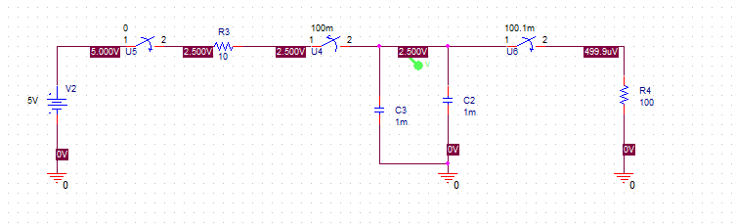

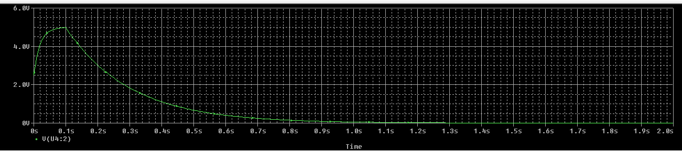

2.

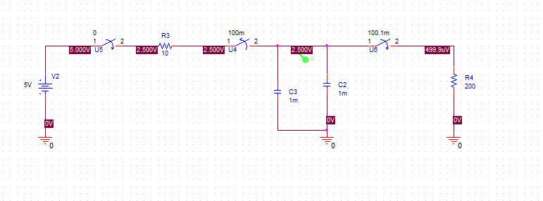

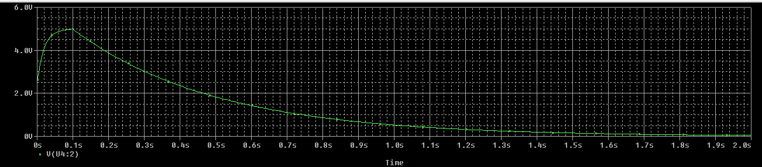

3.